**DHCP Configuration**

Student Version



Huawei Technologies Co., Ltd.

|  |
| --- |
| **Copyright © Huawei Technologies Co., Ltd. 2020. All rights reserved.**  No part of this document may be reproduced or transmitted in any form or by any means without prior written consent of Huawei Technologies Co., Ltd.  **Trademarks and Permissions**  HW_POS_RBG_Vertical-150ppi.png and other Huawei trademarks are trademarks of Huawei Technologies Co., Ltd.  All other trademarks and trade names mentioned in this document are the property of their respective holders.  **Notice**  The purchased products, services and features are stipulated by the contract made between Huawei and the customer. All or part of the products, services and features described in this document may not be within the purchase scope or the usage scope. Unless otherwise specified in the contract, all statements, information, and recommendations in this document are provided "AS IS" without warranties, guarantees or representations of any kind, either express or implied.  The information in this document is subject to change without notice. Every effort has been made in the preparation of this document to ensure accuracy of the contents, but all statements, information, and recommendations in this document do not constitute a warranty of any kind, express or implied. |

|  |  |
| --- | --- |
| Huawei Technologies Co., Ltd. | |
| Address: | Huawei Industrial Base  Bantian, Longgang  Shenzhen 518129  People's Republic of China |
| Website: | <https://e.huawei.com/> |

**Huawei Certification System**

Huawei Certification follows the "platform + ecosystem" development strategy, which is a new collaborative architecture of ICT infrastructure based on "Cloud-Pipe-Terminal". Huawei has set up a complete certification system consisting of three categories: ICT infrastructure certification, platform and service certification, and ICT vertical certification. It is the only certification system that covers all ICT technical fields in the industry. Huawei offers three levels of certification: Huawei Certified ICT Associate (HCIA), Huawei Certified ICT Professional (HCIP), and Huawei Certified ICT Expert (HCIE). Huawei Certification covers all ICT fields and adapts to the industry trend of ICT convergence. With its leading talent development system and certification standards, it is committed to fostering new ICT talent in the digital era, and building a sound ICT talent ecosystem.

Huawei Certified ICT Associate-Datacom (HCIA-Datacom) is designed for Huawei's frontline engineers and anyone who want to understand Huawei's datacom products and technologies. The HCIA-Datacom certification covers routing and switching principles, basic WLAN principles, network security basics, network management and O&M basics, SDN and programmability and automation basics.

The Huawei certification system introduces the industry, fosters innovation, and imparts cutting-edge datacom knowledge.

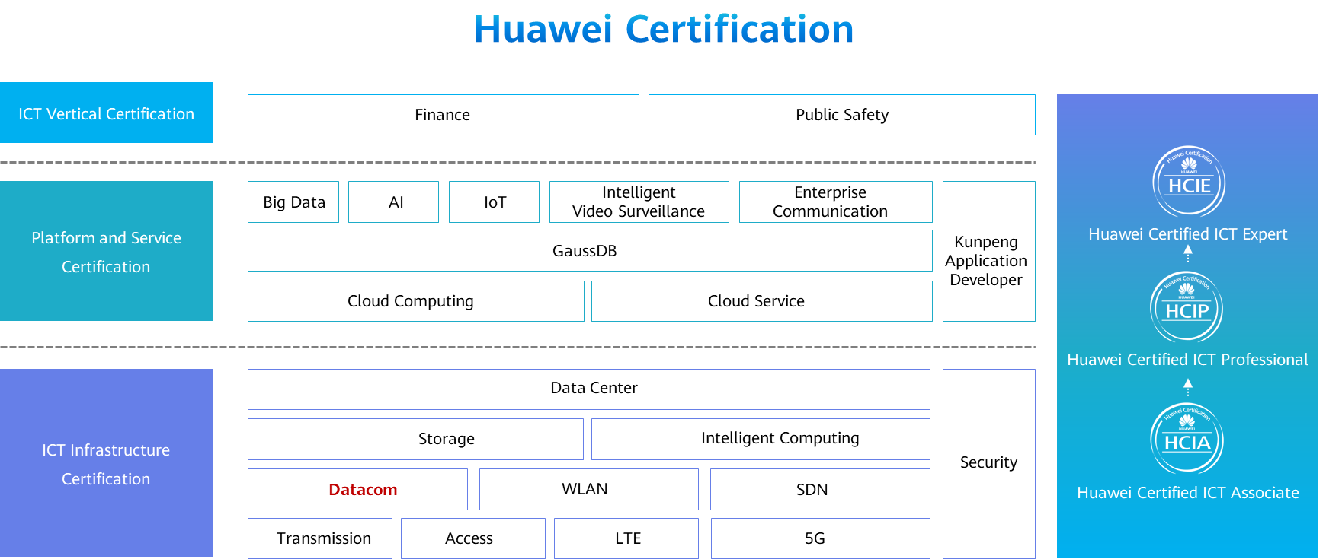

# DHCP Configuration

## Background

The Dynamic Host Configuration Protocol (DHCP) dynamically configures and uniformly manages IP addresses of hosts. It simplifies network deployment and scale-out, even for small networks.

DHCP is defined in RFC 2131 and uses the client/server communication mode. A client (DHCP client) requests configuration information from a server (DHCP server), and the server returns the configuration information allocated to the client.

DHCP supports dynamic and static IP address allocation.

Dynamic allocation: DHCP allocates an IP address with a limited validity period (known as a lease) to a client. This mechanism applies to scenarios where hosts temporarily access the network and the number of idle IP addresses is less than the total number of hosts.

Static allocation: DHCP allocates fixed IP addresses to clients as configured. Compared with manual IP address configuration, DHCP static allocation prevents manual configuration errors and enables unified maintenance and management.

## Objectives

Upon completion of this task, you will be able to:

Learn how to configure an interface address pool on the DHCP server

Learn how to configure a global address pool on the DHCP server

Learn how to use DHCP to allocate static IP addresses

## Topology

Lab Topology

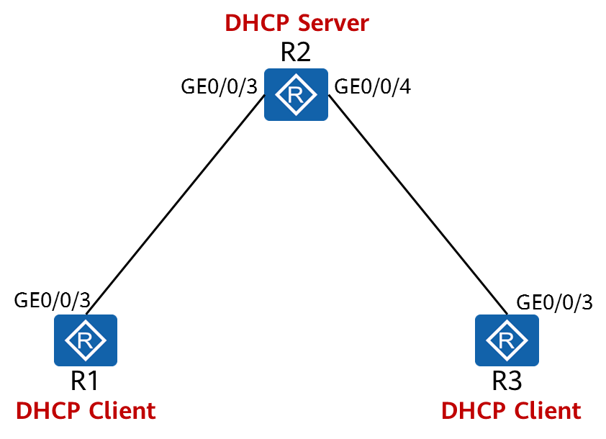

To reduce the workload of IP address maintenance and improve IP address utilization, an enterprise plans to deploy DHCP on the network.

1. Configure R1 and R3 as DHCP clients.
2. Configure R2 as the DHCP server to assign IP addresses to R1 and R3.

## Implementation

### Roadmap

1. Configure the DHCP server.
2. Configure the DHCP clients.

### Procedure

Complete basic configurations.

# Configure interface addresses on R2.

[R2]interface GigabitEthernet 0/0/3

[R2-GigabitEthernet0/0/3] ip address 10.0.12.2 24

[R2-GigabitEthernet0/0/3]quit

[R2]interface GigabitEthernet 0/0/4

[R2-GigabitEthernet0/0/4]ip address 10.0.23.2 24

[R2-GigabitEthernet0/0/4]quit

Enable DHCP.

[R1]

The **dhcp enable** command must be executed before executing any other DHCP-related commands, regardless for DHCP servers or clients.

[R2]

[R3]

Configure an address pool.

# Configure an IP address pool on GE 0/0/3 of R2 to assign an IP address to R1.

[R2]interface GigabitEthernet 0/0/3

[R2-GigabitEthernet0/0/3]

The **dhcp select interface** command enables an interface to use the interface address pool. If you do not run this command, parameters related to the interface address pool cannot be configured.

[R2-GigabitEthernet0/0/3]

The **dhcp server dns-list** command configures DNS server addresses for an interface address pool. A maximum of eight DNS server addresses can be configured. These IP addresses are separated by spaces.

# Configure a global address pool.

[R2]ip pool GlobalPool

Info: It's successful to create an IP address pool.

# Create an IP address pool named GlobalPool.

[R2-ip-pool-GlobalPool]

The **network** command specifies a network address for a global address pool.

[R2-ip-pool-GlobalPool]

[R2-ip-pool-GlobalPool]

The **gateway-list** command configures a gateway address for a DHCP client. After R3 obtains an IP address, it generates a default route with the next-hop address being 10.0.23.2.

[R2-ip-pool-GlobalPool]

The **lease** command specifies the lease for IP addresses in a global IP address pool. If the lease is set to **unlimited**, the lease is unlimited. By default, the lease of IP addresses is one day.

[R2-ip-pool-GlobalPool]

The **static-bind** command binds an IP address in a global address pool to a MAC address of a client. 00e0-fc6f-6d1f is the MAC address of GigabitEthernet0/0/3 on R3. You can run the **display interface GigabitEthernet0/0/3** command on R3 to display the MAC address of GigabitEthernet0/0/3. After the command is executed, R3 obtains the fixed IP address of 10.0.23.3.

[R2-ip-pool-GlobalPool]quit

Enable the DHCP server function on GigabitEthernet 0/0/4 of R2 to assign an IP address to R3.

[R2]interface GigabitEthernet 0/0/4

[R2-GigabitEthernet0/0/4]

The **dhcp select global** command enables an interface to use the global address pool. After receiving a request from a DHCP client, the interface searches the global address pool for an available IP address and assigns the IP address to the DHCP client.

Configure a DHCP client.

[R1]interface GigabitEthernet 0/0/3

[R1-GigabitEthernet0/0/3]

[R3]interface GigabitEthernet 0/0/3

[R3-GigabitEthernet0/0/3]

**----End**

* 1. **Verification**

Display the IP addresses and routes of R1 and R3.

[R1]display ip interface brief

Interface IP Address/Mask Physical Protocol

GigabitEthernet0/0/3  **10.0.12.254/24**  up up

*Only key information is provided here. The command output shows that R1 has obtained an IP address.*

[R1]display dns server

Type:

D:Dynamic S:Static

No. Type IP Address

1 D 10.0.12.2

*Only key information is provided here. The command output shows that R1 has obtained the DNS address.*

[R1]display ip routing-table

Destination/Mask Proto Pre Cost Flags NextHop Interface

0.0.0.0/0 **Unr** 60 0 D 10.0.12.2 GigabitEthernet0/0/3

*Only key information is provided here. The command output shows that R1 has obtained the default route.*

[R3]display ip interface brief

Interface IP Address/Mask Physical Protocol

GigabitEthernet0/0/3  **10.0.23.3/24**  up up

*Only key information is provided here. The command output shows that R3 has obtained a fixed IP address.*

[R3]display dns server

Type:

D:Dynamic S:Static

No. Type IP Address

1 D 2.23.0.10

*Only key information is provided here. The command output shows that R3 has obtained the DNS address.*

[R3]display ip routing-table

Route Flags: R - relay, D - download to fib

------------------------------------------------------------------------------

Routing Tables: Public

Destinations : 8 Routes : 8

Destination/Mask Proto Pre Cost Flags NextHop Interface

0.0.0.0/0 Unr 60 0 D 10.0.23.2 GigabitEthernet0/0/3

*Only key information is provided here. The command output shows that R3 has obtained the default route.*

Display the address allocation on R2.

[R2]display ip pool name GlobalPool

Pool-name : GlobalPool

Pool-No : 1

Lease : 2 Days 2 Hours 0 Minutes

Domain-name : -

DNS-server0 : 10.0.23.2

NBNS-server0 : -

Netbios-type : -

Position : Local Status : Unlocked

Gateway-0 : **10.0.23.2**

Mask : **255.255.255.0**

VPN instance : --

-----------------------------------------------------------------------------

Start End Total Used Idle(Expired) Conflict Disable

-----------------------------------------------------------------------------

10.0.23.1 10.0.23.254 253  **1**  252(0) 0 0

-----------------------------------------------------------------------------

The **display ip pool** command displays the address pool configuration information, including the name, lease, lock status, and IP address status.

[R2]display ip pool interface GigabitEthernet0/0/4

Pool-name : **GigabitEthernet0/0/4**

Pool-No : 0

Lease : 1 Days 0 Hours 0 Minutes

Domain-name : -

DNS-server0 : **10.0.12.2**

NBNS-server0 : -

Netbios-type : -

Position : Interface Status : Unlocked

Gateway-0 : **10.0.12.2**

Mask : 255.255.255.0

VPN instance : --

-----------------------------------------------------------------------------

Start End Total Used Idle(Expired) Conflict Disable

-----------------------------------------------------------------------------

10.0.12.1 10.0.12.254 253 **1**  252(0) 0 0

-----------------------------------------------------------------------------

When an interface address pool is configured, the name of the address pool is the interface name. The allocated gateway address is the IP address of the interface and cannot be changed.